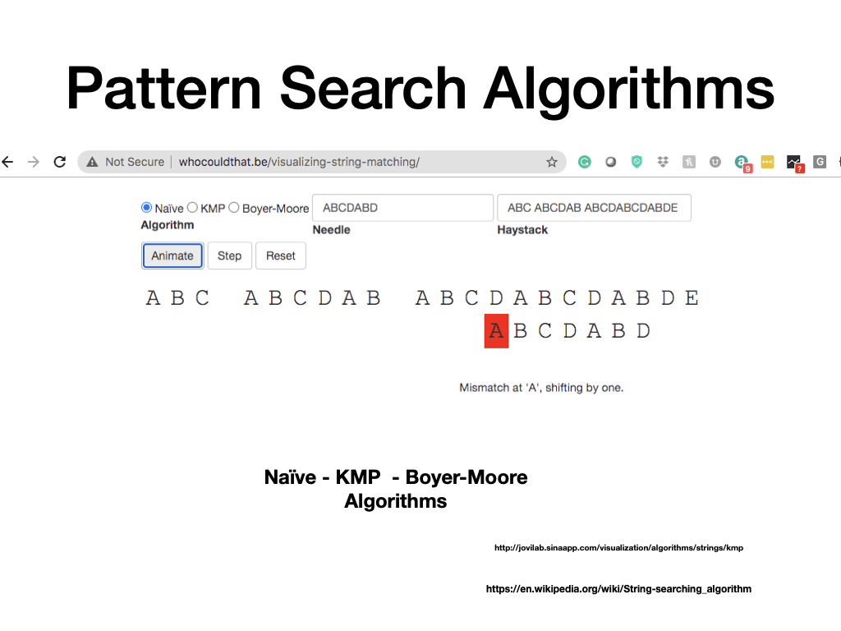

<http://jovilab.sinaapp.com/visualization/algorithms/strings/kmp>